

Internet of things lab ASSIGNMENT

Course code: CSE-402

Submitted to:

Ayanava Paul

Lecturer, UITS



Submitted By:

Md. Shakibul Islam Ramim

ID: 2125051063

Batch: CSE-50

Section: 7B1

Email: 2125051063@uits.edu.bd

## Display Information using UNO R3

### Title: Display your name and student ID in the first and second row respectively of the LCD. Also show them in serial monitor.

### Necessary Equipment:

1. Arduino UNO R3
2. Breadboard
3. 330 Ohm resistor
4. One LED
5. 16*2

### Circuit Figure:

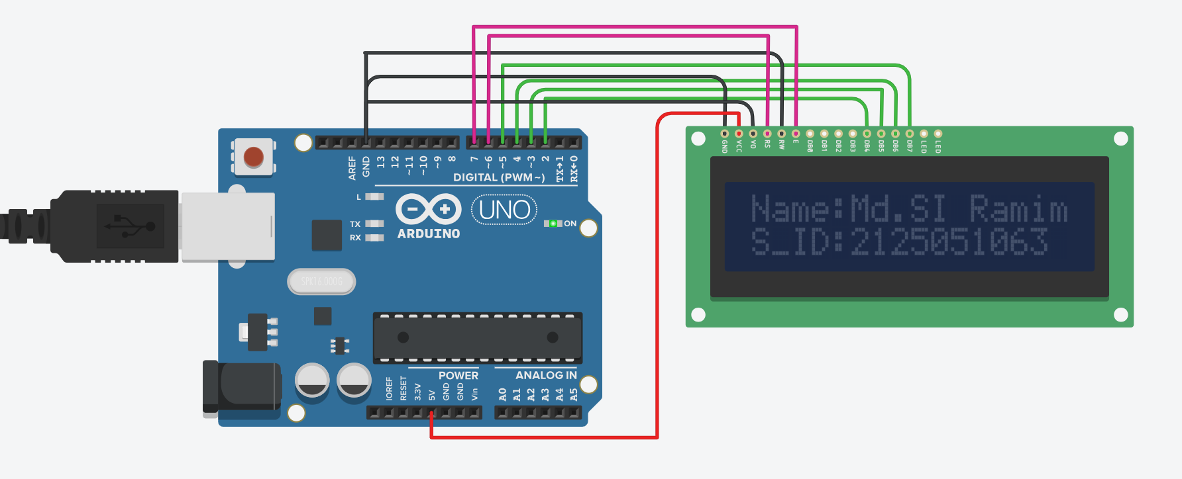

### Code:

#include <LiquidCrystal.h>

char name[] ="Name:Md.SI Ramim";

char student_id[] = "S_ID:2125051063";

LiquidCrystal lcd(6,7,2,3,4,5); // Rs, E, D4, D5 D6, D7

void setup()

{

lcd.begin(16,2);

Serial.begin(9600);

delay(1000);

}

void loop()

{

lcd.setCursor(0,0);

lcd.print(name);

Serial.println(name);

lcd.setCursor(0,1);

lcd.print(student_id);

Serial.println(student_id);

delay(2000);

}

## Even, odd position light blink

### Title: Build a mini LED array project with Arduino where at first the LEDs at odd position will be blinked serially. Then the LEDs at an even position will be blinked serially. Take 5 LED

### Necessary Equipment:

1. Arduino UNO R3
2. Breadboard
3. 330 Ohm resistor
4. 5 LED

### Circuit Figure:

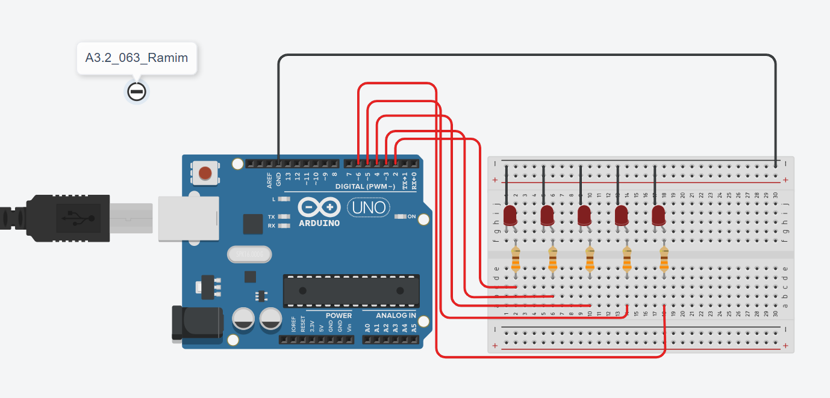

Code:

// C++ code

int even_pos[] = {2,4,6};

int odd_pos[] = {3,5};

void setup()

{

int even_arr = 0;

int odd_arr = 0;

for(int i = 0; i < 5; i++){

if(i%2==0){

pinMode(even_pos[even_arr], OUTPUT);

even_arr++;

}else{

pinMode(odd_pos[odd_arr], OUTPUT);

odd_arr++;

}

}

Serial.begin(9600);

delay(1000);

}

void loop()

{

for(int i = 0; i < 2; i++){

digitalWrite(odd_pos[i], 1);

delay(1000);

Serial.println(odd_pos[i]);

delay(1000);

digitalWrite(odd_pos[i], 0);

delay(100);

}

for(int i = 0; i < 3; i++){

digitalWrite(even_pos[i], 1);

delay(1000);

Serial.println(even_pos[i]);

delay(1000);

digitalWrite(even_pos[i], 0);

delay(100);

}

}

The End